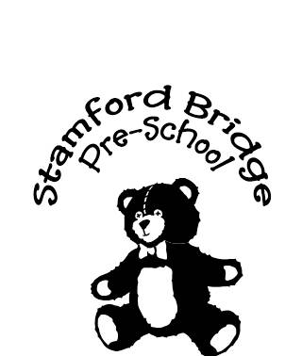

Registered Charity No : 1037322
stamfordbridgepreschool@gmail.com
07982 834159

Dear Parent
The Early Years Pupil Premium
From April 2015, pre-schools, nurseries, schools and childminders have been able to
claim extra funding through the Early Years Pupil Premium to support children’s
development, learning and care. This letter explains who is eligible for this funding and
why it is so important that you agree for your eligibility to be checked, so that we can
claim the extra funding.
The Early Years Pupil Premium provides an extra 53 pence per hour for all three and
four year old children who are receiving free early education and who meet the eligibility
criteria below. This means an extra £302 a year for each child taking up the full 570
hours funded entitlement to early education. We can use the extra funding in any way
we choose to improve the quality of the early years education for your child and we will
continually be looking at new ways to make the most of this. This could include buying
resources such as story sacks to develop early language, support small group work for
children, investing in partnership working with our colleagues to further our expertise or
supporting our staff in working on specialised areas such as speech and language.
Eligible children are those where:
a) the family is in receipt of any of the benefits listed below:
• Income Support
• Income-based Jobseekers Allowance
• Income-related Employment and Support Allowance
• Support under part 6 of the Immigration and Asylum Act 1999
• the guarantee element of State Pension Credit
• Child Tax Credit (with no Working Tax Credit) with an annual gross income of no
more than £16,190
• Working Tax Credit run-on
• Universal Credit
b) they are currently being looked after by the a local authority
c) they have left care through
• an adoption
• a special guardianship or child arrangement order
The information you provide will be used by the Local Authority to confirm receipt of one
of the listed welfare benefits. They will do this by checking out of work benefit data
provided by HMRC and DWP. You are free to withdraw your consent at any time so that
your details are not used in future. Whether you agree to this or not, it will not affect any
of the benefits you may be entitled to.
For children who have been adopted from care or are subject to a special guardianship
order or a child arrangements order, eligibility will be based on your declaration that
your child was formally a looked after child and on the evidence of their status, (e.g. a
copy of the relevant order.) If you would rather not share this information with your
child’s setting or childminder then please ring the Families Information Service Hub
(FISH) team on (01482) 396469.
National data and research tells us that children eligible for free school meals tend to do
less well, for example in 2014 45% of children eligible for free school meals achieved
the expected level at the end of the early years foundation stage compared with 64% of
other children. The Early Years Pupil Premium will provide us with extra funding to
close this gap.
It is well documented that high quality early education can influence how well a child
does at both primary and secondary school so we do want to make the most of this
additional funding. You may be aware if you have older children that a pupil premium
has been available for school age children and it has proved to have given a real boost
to the children receiving the funding. We want to do the same for our early years
children entitled to this funding.
Therefore we ask that ALL PARENTS/GUARDIANS agree to have their entitlement
checked. This will allow us to claim the additional Early Years Pupil Premium.
Yours faithfully
Stamford Bridge Pre-school

