Stamford Bridge Pre-school
HEALTH & SICKNESS POLICY
The Pre-school seeks to promote and encourage good health and hygiene for all the children and staff accessing the provision. If a child has any infectious disease we request parents inform us of this. Exclusion periods for childhood illnesses vary, the below table illustrates the incubation period and exclusion periods for the most common childhood illnesses. It should be said that if there is an outbreak of an illness at the Pre-school these exclusion periods may be extended to protect other children and staff where appropriate, the information on this list is informed by UKHSA ‘Guidance on exclusions & infection control’.
If in doubt as to whether your child is well enough to attend, please seek advice from the Pre-school Manager or your GP. If a child is visibly under the weather it may be wise to allow your child a day at home to rest.
Children taking antibiotics should not attend until 24 hours after treatment has commenced and then only if they are actually getting better.
Infection | Exclusion period | Comments
Athlete’s foot | None | Individuals should not be barefoot at their setting (for example in changing areas) and should not share towels, socks or shoes with others.
Chickenpox | At least 5 days from onset of rash and until all blisters have crusted over. | Pregnant staff contacts should consult with their GP or midwife.
Cold sores (herpes simplex) | None | Avoid kissing and contact with the sores.
Conjunctivitis | None | If an outbreak or cluster occurs, contact your local UKHSA health protection team.
Respiratory infections including coronavirus (COVID-19) | Individuals should not attend if they have a high temperature and are unwell.  Individuals who have a positive test result for COVID-19 should not attend the setting for 3 days after the day of the test. | Individuals with mild symptoms such as runny nose, and headache who are otherwise well can continue to attend their setting.
Diarrhoea and vomiting | Individuals can return 48 hours after diarrhoea and vomiting have stopped. | If a particular cause of the diarrhoea and vomiting is identified, there may be additional exclusion advice, for example E. coli STEC and hep A.  For more information, see Managing outbreaks and incidents.
Diptheria* | Exclusion is essential.  Always contact your local UKHSA health protection team. | Preventable by vaccination. For toxigenic Diphtheria, only family contacts must be excluded until cleared to return by your local UKHSA health protection team.
Flu (influenza) or influenza like illness | Until recovered | Report outbreaks to your local UKHSA health protection team.  For more information, see Managing outbreaks and incidents.
Glandular fever | None
Hand foot and mouth | None | Contact your local UKHSA health protection team if a large number of children are affected. Exclusion may be considered in some circumstances.
Head lice | None
Hepititis A | Exclude until 7 days after onset of jaundice (or 7 days after symptom onset if no jaundice). | In an outbreak of hepatitis A, your local UKHSA health protection team will advise on control measures.
Hepatitis B, C, HIV | None | Hepatitis B and C and HIV are blood borne viruses that are not infectious through casual contact.  Contact your local UKHSA health protection team for more advice.
Impetigo | Until lesions are crusted or healed, or 48 hours after starting antibiotic treatment. | Antibiotic treatment speeds healing and reduces the infectious period.
Measles | 4 days from onset of rash and well enough. | Preventable by vaccination with 2 doses of MMR.  Promote MMR for all individuals, including staff. Pregnant staff contacts should seek prompt advice from their GP or midwife.
Meningococcal meningitis* or septicaemia* | Until recovered | Meningitis ACWY and B are preventable by vaccination.  Your local UKHSA health protection team will advise on any action needed.
Meningitis* due to other bacteria | Until recovered | Hib and pneumococcal meningitis are preventable by vaccination. Your local UKHSA health protection team will advise on any action needed.
Meningitis viral | None | Milder illness than bacterial meningitis. Siblings and other close contacts of a case need not be excluded.
MRSA | None | Good hygiene, in particular handwashing and environmental cleaning, are important to minimise spread.  Contact your local UKHSA health protection team for more information.
Mumps* | 5 days after onset of swelling | Preventable by vaccination with 2 doses of MMR. Promote MMR for all individuals, including staff.
Ringworm | Not usually required | Treatment is needed.
Rubella* (German measles) | 5 days from onset of rash | Preventable by vaccination with 2 doses of MMR.  Promote MMR for all individuals, including staff. Pregnant staff contacts should seek prompt advice from their GP or midwife.
Scabies | Can return after first treatment. | Household and close contacts require treatment at the same time.
Scarlet fever* | Exclude until 24 hours after starting antibiotic treatment. | Individuals who decline treatment with antibiotics should be excluded until resolution of symptoms. In the event of 2 or more suspected cases, please contact your local UKHSA health protection team.
Slapped cheek/Fifth disease/Parvovirus B19 | None (once rash has developed) | Pregnant contacts of case should consult with their GP or midwife.
Threadworms | None | Treatment recommended for child and household.
Tonsillitis | None | There are many causes, but most cases are due to viruses and do not need or respond to an antibiotic treatment.
Tuberculosis* (TB) | Until at least 2 weeks after the start of effective antibiotic treatment (if pulmonary TB.  Exclusion not required for non-pulmonary or latent TB infection.  Always contact your local UKHSA health protection team before disseminating information to staff, parents and carers, and students. | Only pulmonary (lung) TB is infectious to others, needs close, prolonged contact to spread.  Your local UKHSA health protection team will organise any contact tracing.
Warts and verrucae | None | Verrucae should be covered in swimming pools, gyms and changing rooms.
Whooping cough (pertussis)* | 2 days from starting antibiotic treatment, or 21 days from onset of symptoms if no antibiotics | Preventable by vaccination.  After treatment, non-infectious coughing may continue for many weeks. Your local UKHSA health protection team will organise any contact tracing.
*denotes a notifiable disease. Registered medical practitioners in England and Wales have a statutory duty to notify their local authority or UK Health Security Agency (UKHSA) health protection team (HPT) of suspected cases of certain infectious diseases.
All laboratories in England performing a primary diagnostic role must notify UKHSA when they confirm a notifiable organism.
Parents are requested to ensure they keep home any child who is presenting with a constant cough.and high temperature. Any child with an unexplained cough and temperature may be sent home with the advice of taking an appropriate Covid 19 test or at least ensuring the child is fit and well before returning.
Where contagious illnesses or conditions are reported to the Pre-school, notification to other parents will be made via notices and sometimes letters/emails, to inform of the presence of this. This notification will be made as soon as is possible after the report to the Pre-school. Please, at this point, if you suspect your child may also be showing signs of the condition, keep them at home and monitor them before returning to the setting. This will hopefully reduce the likelihood of further contraction by other children.
If you have any suspicion that your child may be carrying a contagious illness/condition, please consult with your GP or seek the advice of a Pharmacist BEFORE bringing your child to the setting.

Implemented by the pre-school on……14.10.21…………………………………………………….
Signed and adopted on behalf of the pre-school by…Zena Jewitt……………………………………

Date to be reviewed……Sept 21………. Reviewed by………DA….. Date……5.9.21…………

Actions required…Hand foot and mouth was added with information from NHS on-line as guidance – information on Covid 19 added ………………………………………………..

Date to be reviewed…Sept 22… Reviewed by…ZJ and DA……….. Date 09.09.22…..
Actions required……Covid and other respiratory diseases – information changed

Date to be reviewed…Sept 23…… Reviewed by…Committee………… Date reviewed: 01.02.23
Actions required…Updated COVID paragraph………………………………………………..

Date to be reviewed…Sept 23… Reviewed by…Committee…… Date reviewed: 26.04.23
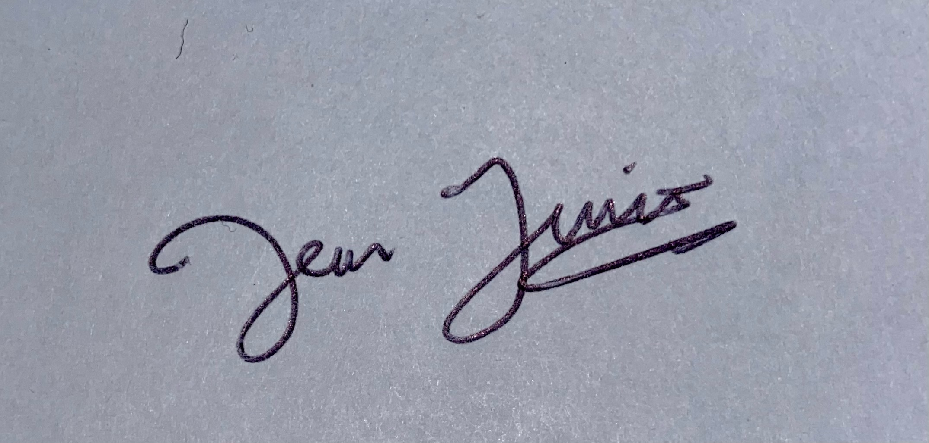
Actions required…………………………………………………..

Date to be reviewed……Oct 23……… Reviewed by…DA………… Date reviewed: 07.11.23
Actions required…UKHSA guidance (Oct 23) used to replace current exclusions table .

